**MODALLA PRANITH REDDY**

**2420030158**

**LAB 5**

**Configuration of Encapsulation dot 1Q using cisco packet tracer**

**Step 1: Launch Cisco Packet Tracer**

* Open **Cisco Packet Tracer** from your desktop or applications list.

**Step 2: Create the Network Topology**

1. **Add Devices:**
   * **Switches**: Add two multilayer switches (**S0** and **S1**).
   * **PCs**: Add 6 PCs.
2. **Connections:**
   * Connect PC0 and PC1 to **S0**.
   * Connect PC2 and PC3 to **S1**.
   * Connect PC4 and PC5 to **S1**.
   * Connect **Fa0/24 of S0** to **Fa0/24 of S1** using a **Cross-Over cable**.

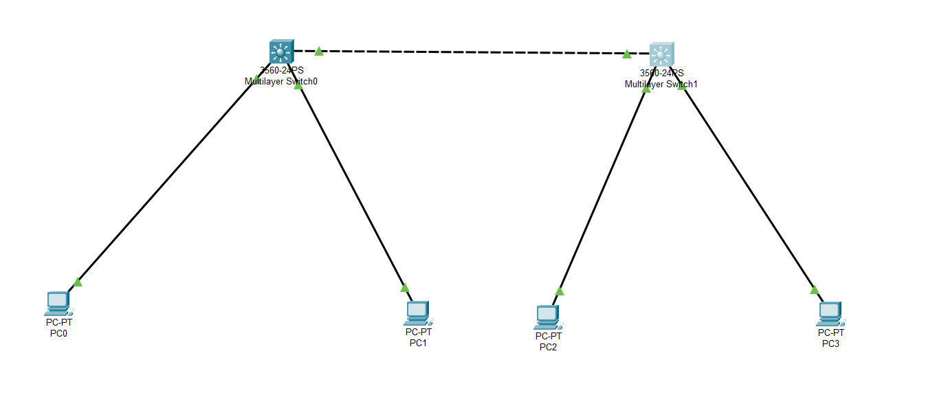

**Step 3: VLAN Creation on Switches**

**On Switch 0 (S0):**

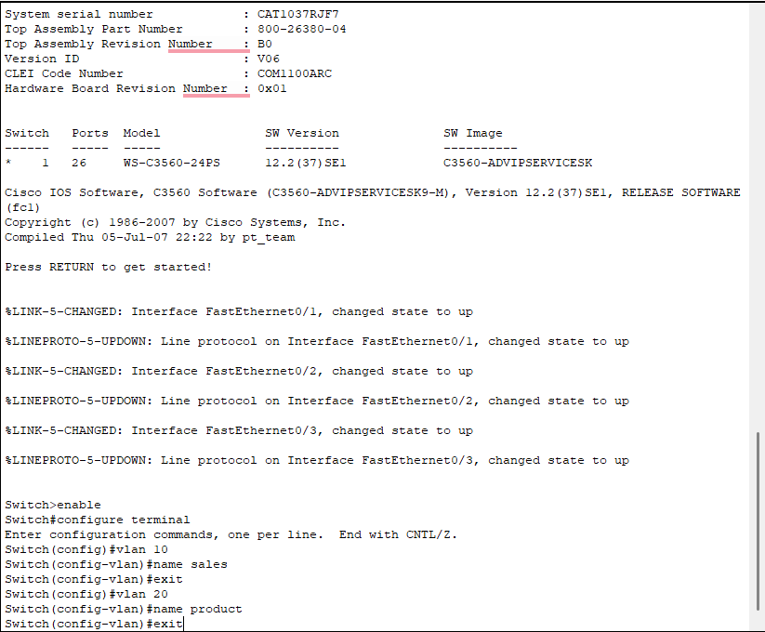

**On Switch 1 (S1):**



**Step 4: Assign Ports to VLANs**

**On SW0:**

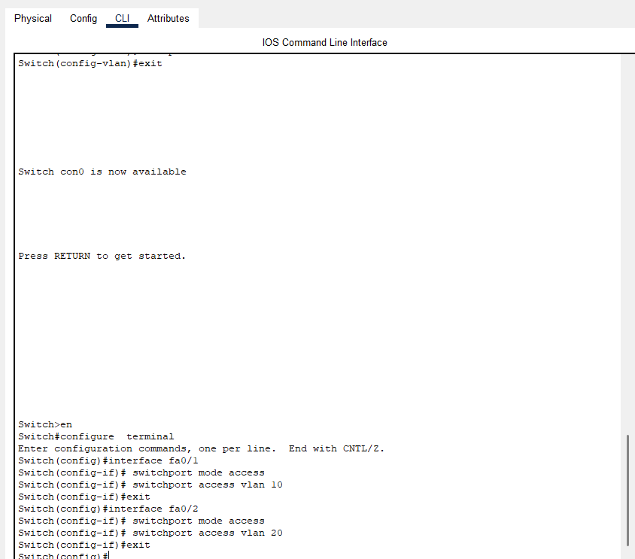

**On SW1:**

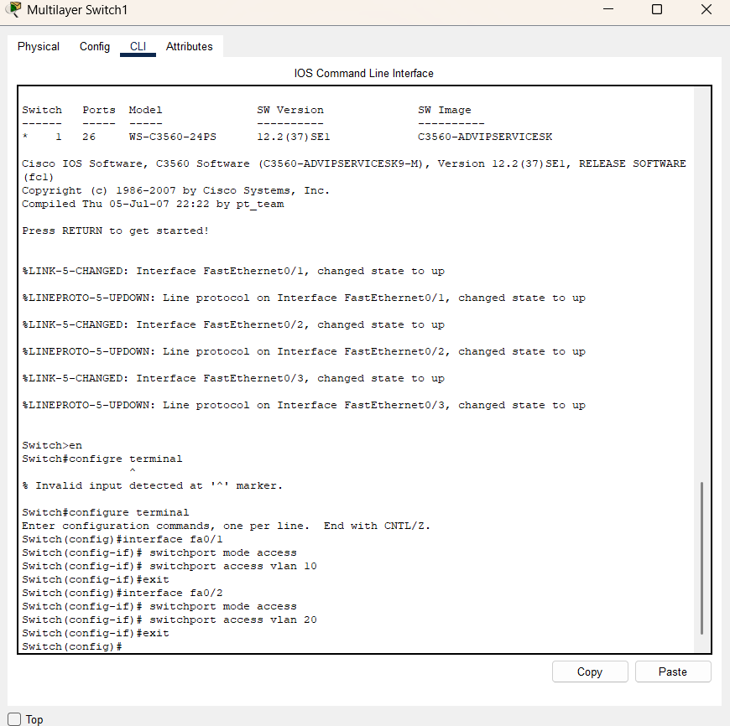

**Step 5: Configure Trunk Ports**

**On SW0:**

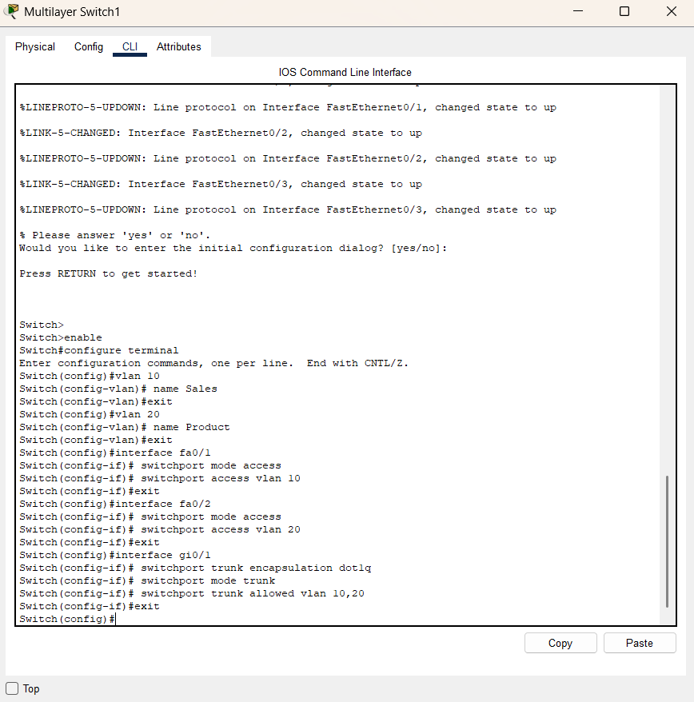

**On SW2:**



| PC | IP Address | Subnet Mask | VLAN |
| --- | --- | --- | --- |
| PC0 | 192.168.10.2 | 255.255.255.0 | 10 |
| PC1 | 192.168.20.2 | 255.255.255.0 | 20 |
| PC2 | 192.168.10.3 | 255.255.255.0 | 10 |
| PC3 | 192.168.20.3 | 255.255.255.0 | 20 |
|  |  |  |  |

**Step 6:On the PCs (Command Prompt in Desktop tab)**

From **PC0 (192.168.10.2, VLAN 10):**

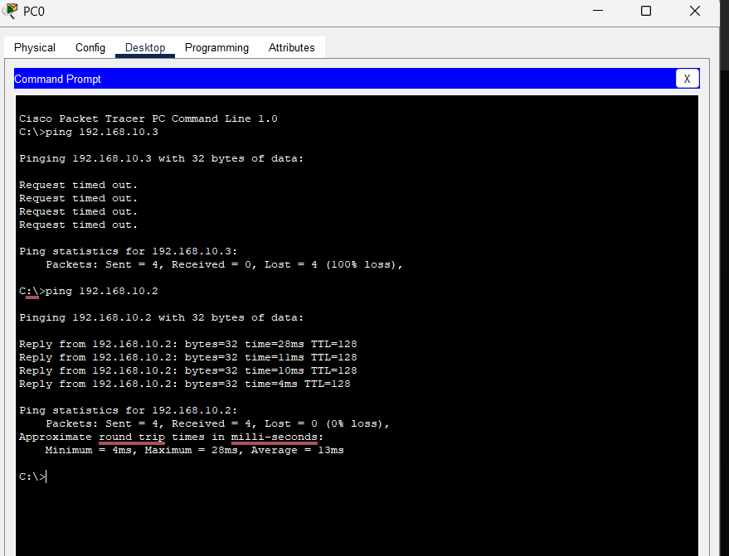

From **PC1 (192.168.20.2, VLAN 20):**



**Step 7: Show the vlan brief**

On **SW1**

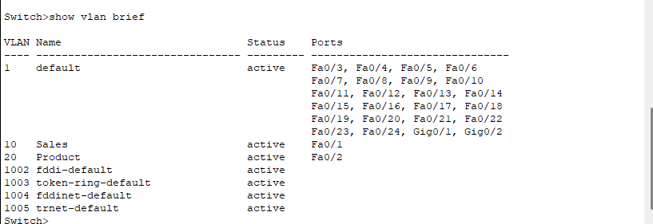

On **SW1**

